

Grower guide to assessing
legume nodulation
Upper Eyre Peninsula

METHOD
1. In late winter or early spring (or about 10 – 12 weeks after sowing), collect about 30 plants, 10 at each of 3 sample spots (see sample pattern diagram), putting each sample of 10 in a separate bucket.
2. Carefully wash off the soil in a bucket of water and rinse roots to remove remaining soil. (Soak for up to 30 min for heavy soils).
3. Score each sample for % plants adequately nodulated and work out average of scoresfor three sampling locations. Float the roots in water on a white background for best results and refer to photos of examples, PTO).
Equipment needed Sample pattern (sample at “x”)
X
X
X
20 m
40 to 50 m
40 to 50 m
Edge of paddock
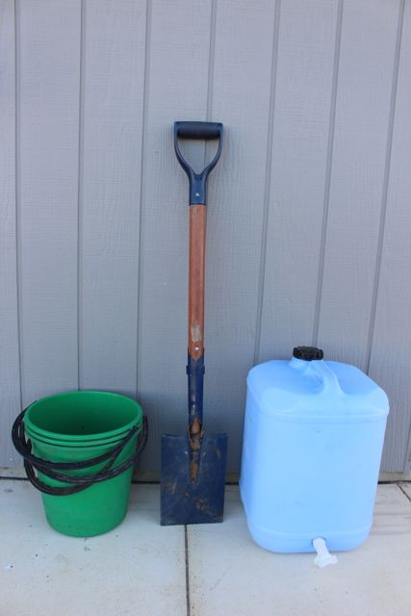

OVERALL AVERAGE SCORE:
Adequate Nodulation similar to or better than “adequate” for 70% or more of plants.
Borderline Nodulation similar to or better than “adequate” for 50 - 70% of plants.
Poor Nodulation similar to or better than “adequate” for less than 50% of plants.
None No nodules present (= no nitrogen fixation)
NOTE: Plants scored as Adequate should have nodules which are a red/pink colour inside.
LUPIN
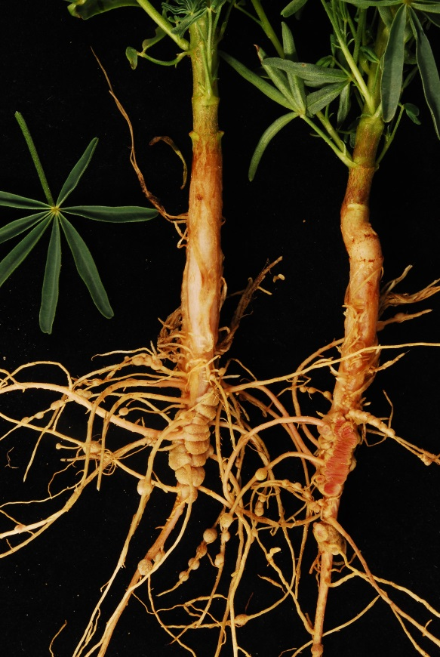
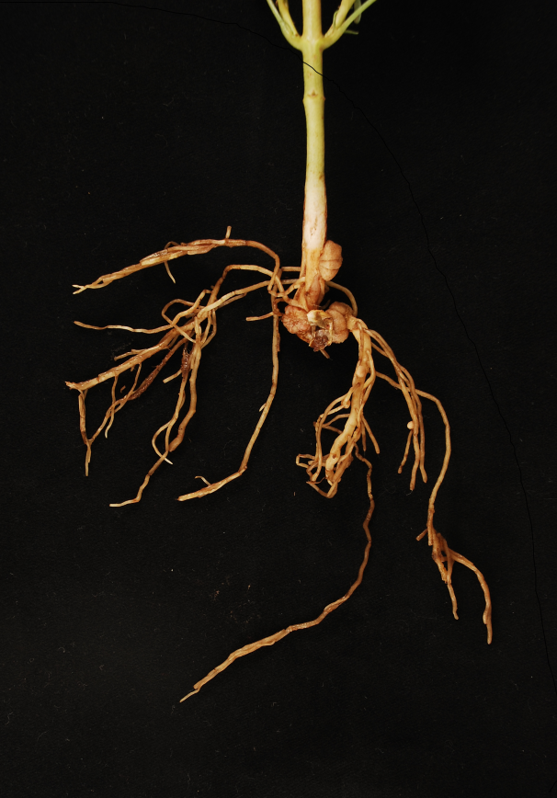
Adequate Poor

Nodules right around the crown & on laterals

PEA
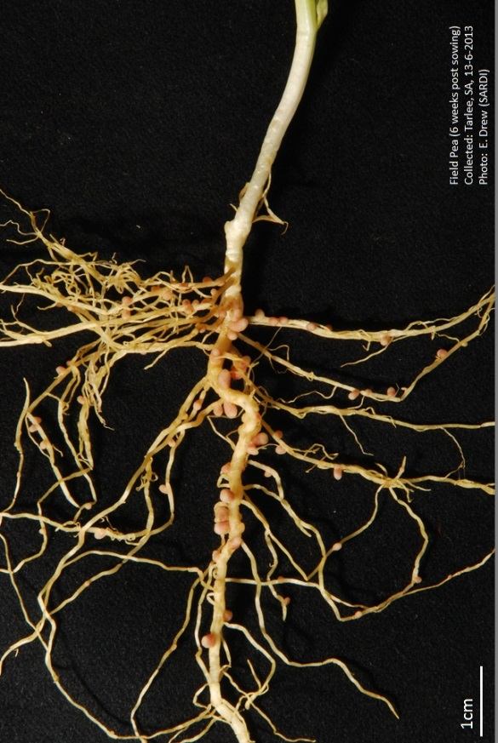
Adequate Poor

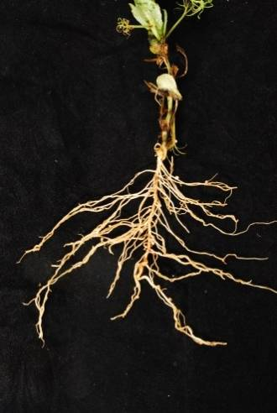

50 to 100 nodules per plant
VETCH as for pea
MEDIC (Sown)
Adequate Poor

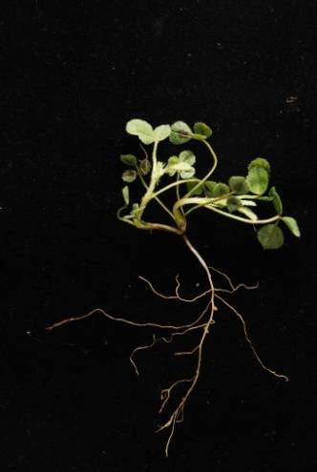
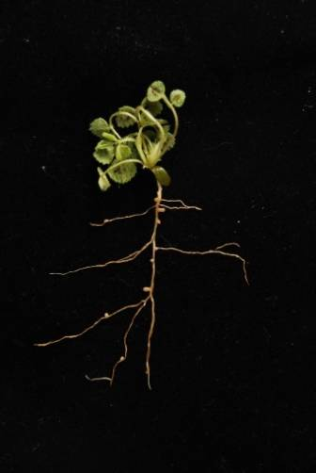

5 to 10 nodules per plant

What if the nodulation score is poor?
1. Sample elsewhere in the paddock to see if it is a localised problem or not.
2. Information on troubleshooting nodulation problems is available in the Nodulation Assessment Guide at http://www.agwine.adelaide.edu.au/research/farming/legumes-nitrogen/legume-inoculation/ (Internet search on: legume growers resources).

Selected troubleshooting questionsfor freshly inoculated legumes: Incorrect inoculant group used? Inoculant mixed with poor quality water (eg saline)? Inoculant combined with pesticides or trace elements? Inoculant combined with fertilizer? Dry sowing into paddock with no background of correct rhizobia? Sowing into extremely acidic soil(except for lupin inoculant)? Was soil waterlogged for an extended period during the growing season? Herbicide damage from previous or current crop? (NOTE: SU herbicides on alkaline soils can dramatically inhibit nodulation of legumes in following years). NOTE: If it is the first time to grow this legume crop in the paddock, the rate of inoculant use can be doubled.

This guide is based on the work of Janine Sounness, formerly pulse agronomist with Agriculture Victoria, Horsham
Maarten Ryder, Senior Extension Officer, University of Adelaide, 2015
maarten.ryder@adelaide.edu.au

